I have kept the entire project very simple, i.e. I have stuck to the basic operations like: Adding new information, Searching new information, deleting the existing information, Updating the existing information, etc. The information regarding the organized crime syndicates is very hard to come by because anything related to the life of these crime bosses or their operations is protected by layers and layers of bureaucratic red tape because of national security reasons.

I still managed to compile data on different parts of the criminal cases like: Criminal ID, the DNA profile of the Criminal, tha name of the criminal, the officers who investigated the case and made the arrests, the name of the case, name of all the witnesses, the place where the crime was committed or we can say the crime scene and the gender of the offender.

1. Cover Page/Home Page:-

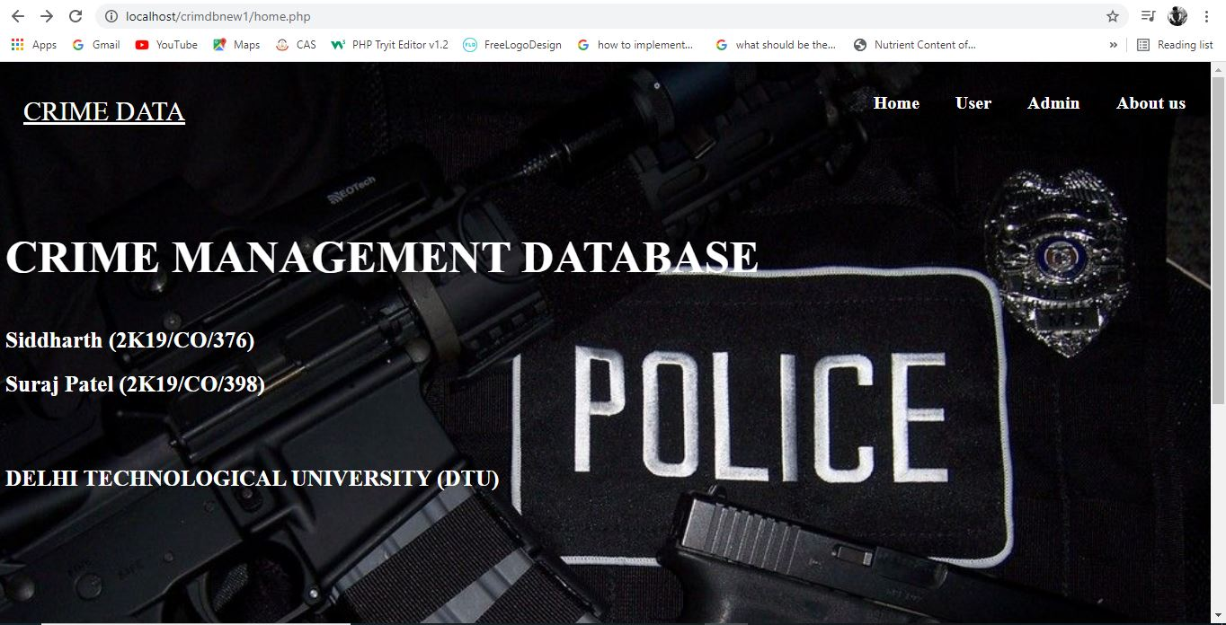

1. Officer Login:-

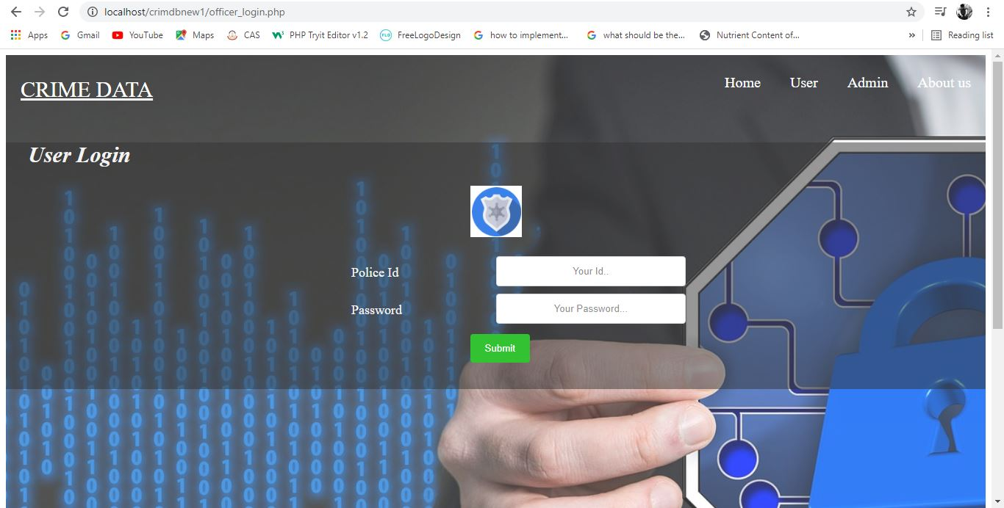

1. Admin Login:-

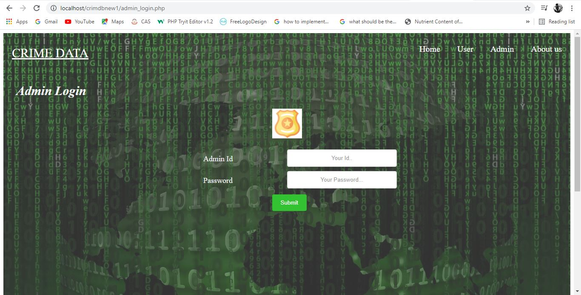

1. Admin Dashboard:-

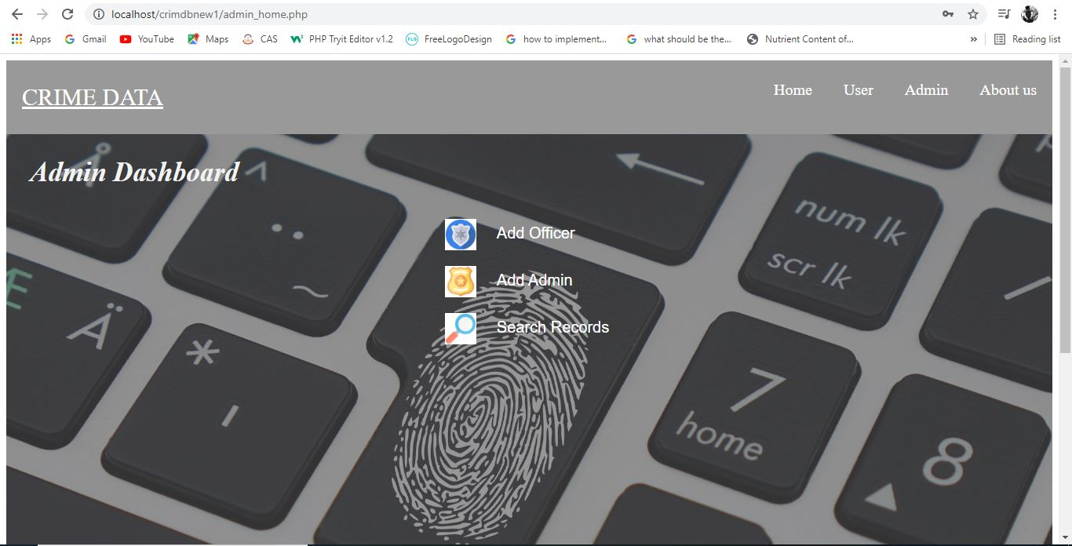

1. Add New Officer:-

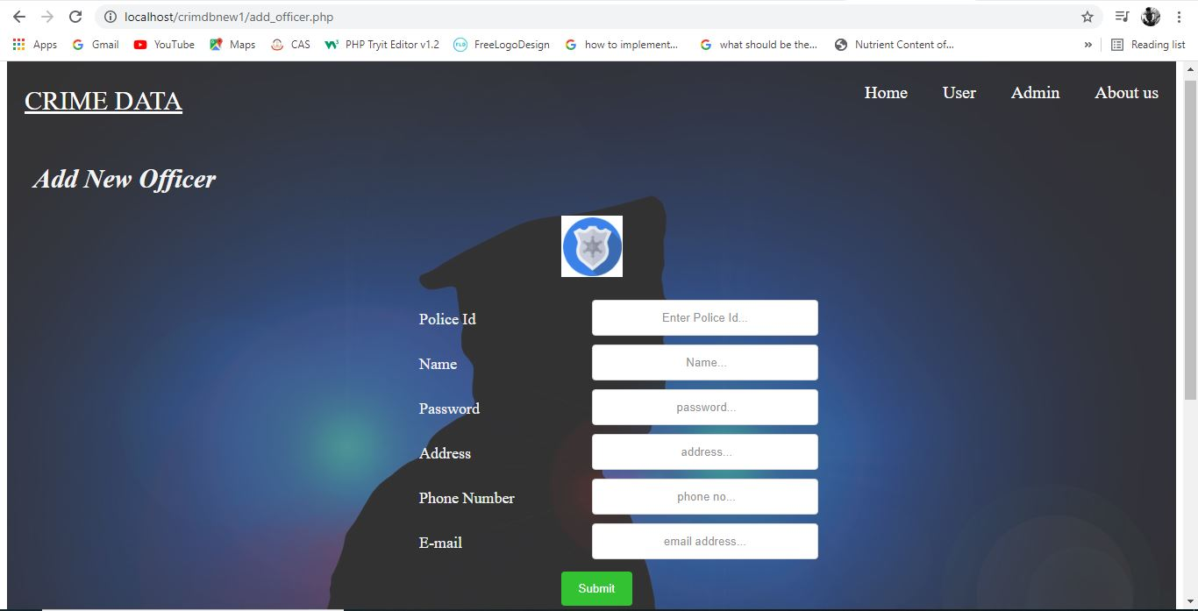

1. Add New Admin:-

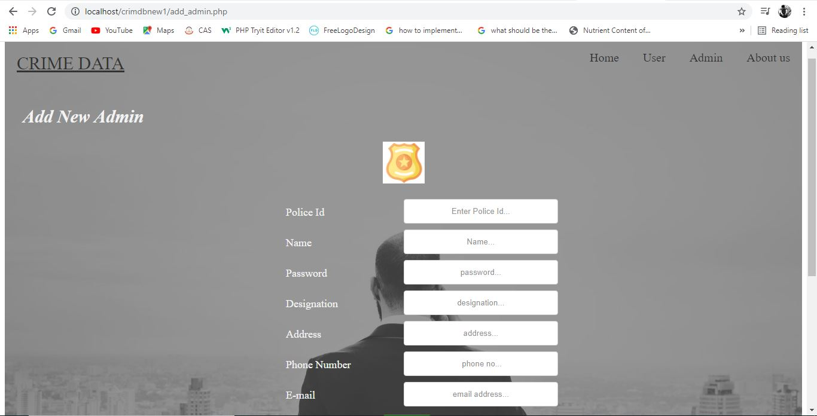

1. Officer Dashboard:-

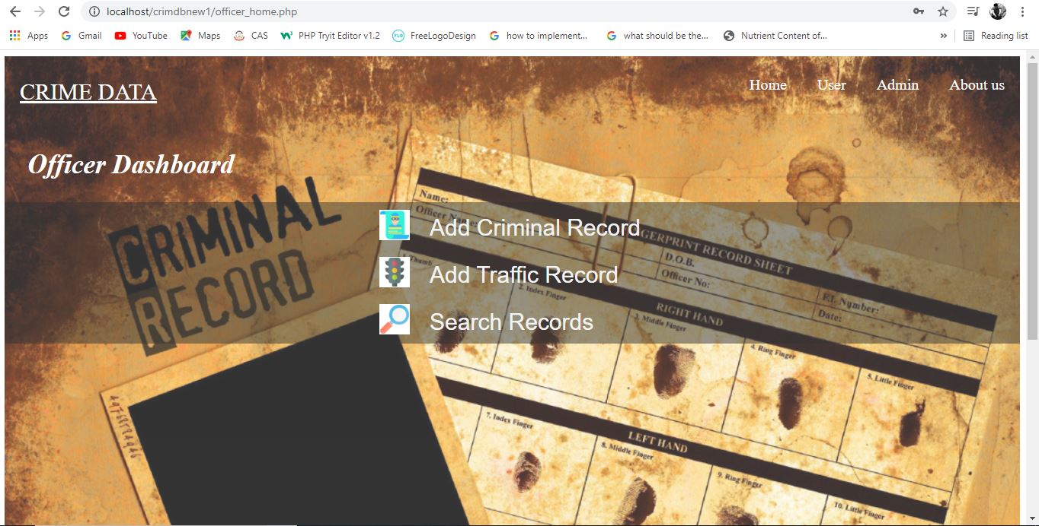

1. Add Crime Record:-

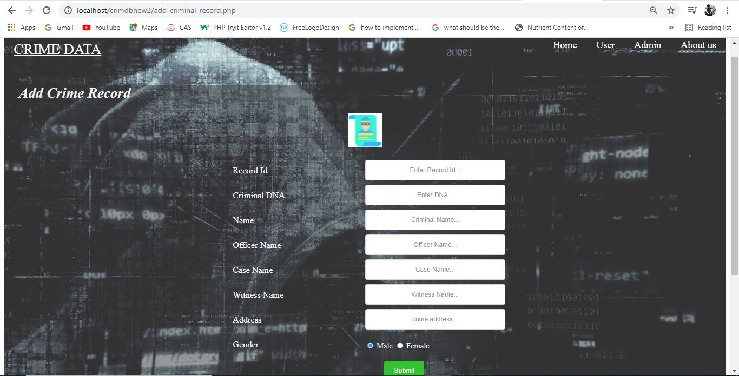

1. Add Traffic Record:-

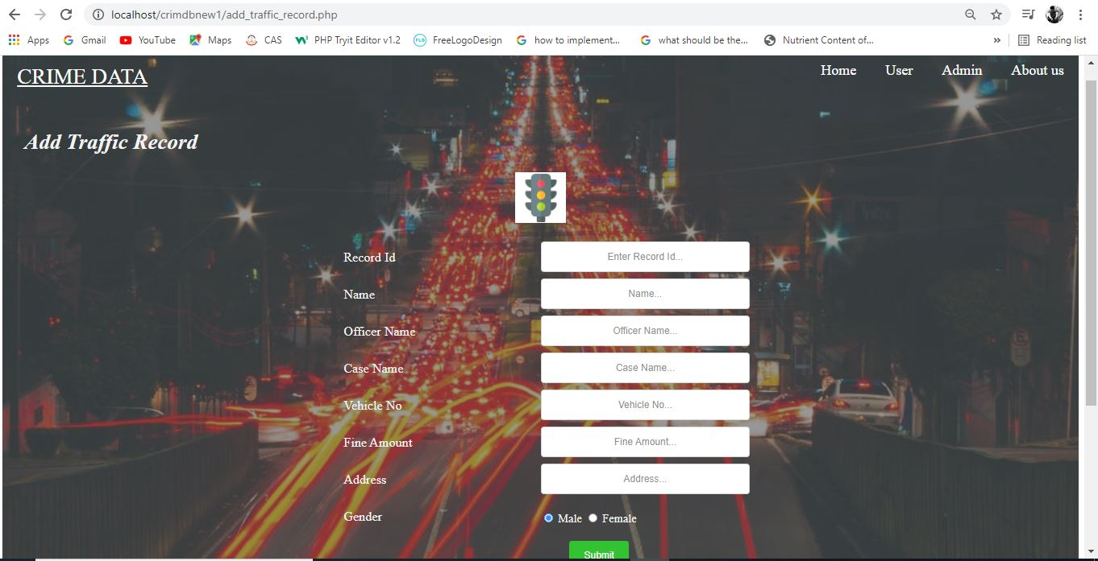

1. About Us Page/Summary:-

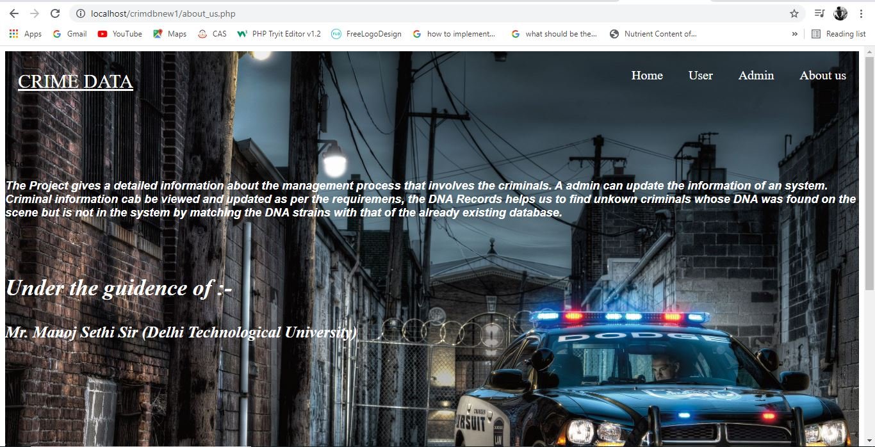

The problem that I encountered was the frontend part, due to my limited knowledge of HTML and PhP; I was able to create a display only for limited amount of information, so I have implemented the program to display the basic information of the crime and the criminal himself, for more detailed information like the case evidence, investigators case diaries, warrants, suspect list, etc we need to make an entirely new database including all this information.

**RESULT**

Search Dashboard:

The search dashboard gives us three options to search, ‘Criminal Records’, ‘Traffic Records’ and ‘Criminal DNA Record’,

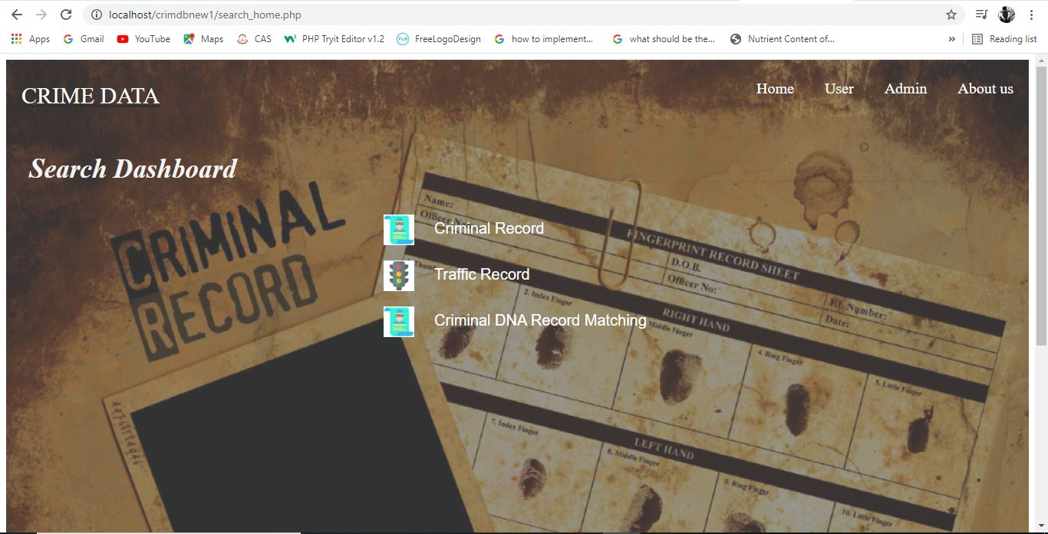

**Crime Record Search:**

The ‘Crime Record Search’ searches all the record on the basis of the criminal record id.

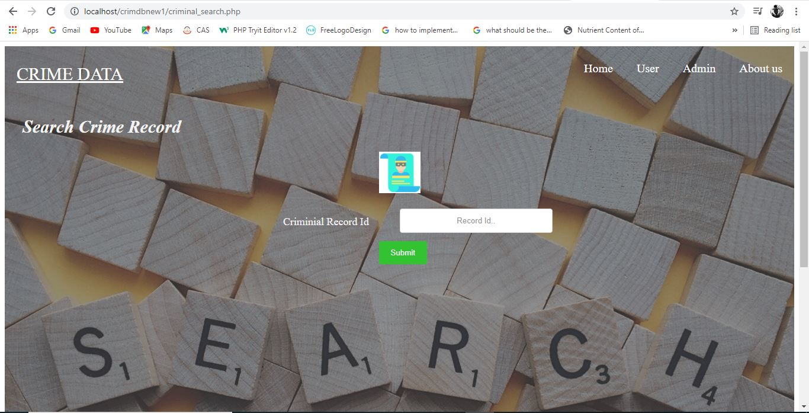

**Traffic Record Search:**

The ‘Traffic Record Search’ searches all the record on the basis of the traffic criminal record id.

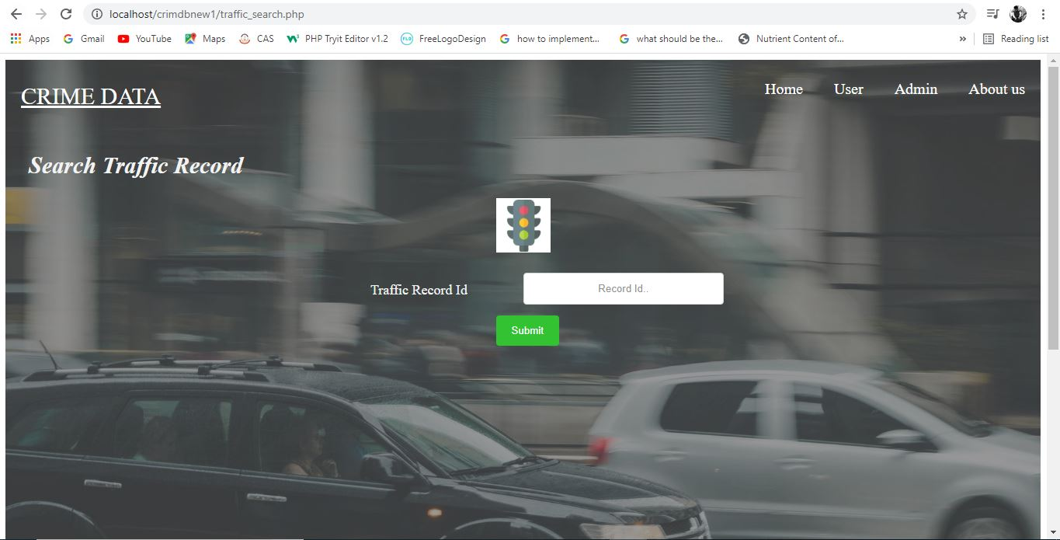

**Criminal DNA Record Search:**

The ‘Criminal DNA Record Search’ searches all the record on the basis of the criminal DNA record.

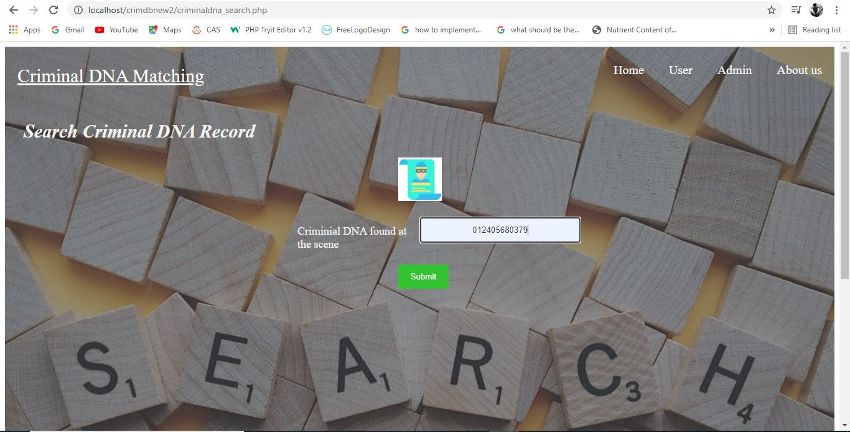

**Criminal Record Search:**

The ‘Crime Record Search’ searches all the record on the basis of the criminal record id, and thus it shows the criminal data without his or her DNA in it.

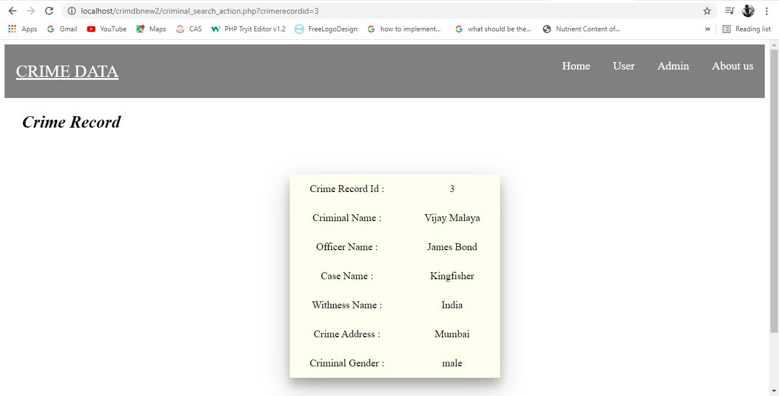

**Criminal DNA Record Search:**

The ‘Criminal DNA Record Search’ searches all the record on the basis of the criminal DNA record and thus it includes the DNA profile of the offender.

